

Customer Retention

Submitted by:

Prabhat Chauhan

**ACKNOWLEDGMENT**

I would like to mention my special thanks to flip robo for constantly providing us the opportunity to work on this projects which helped me to learn new things, and I also pay my sincere thanks to sajid Chaudhary sir for providing the support that is needed in between the projects, with his guidance I learned a lot and will continue to do so.

**INTRODUCTION**

* Business Problem Framing

Describe the business problem and how this problem can be related to the real world.

* Conceptual Background of the Domain Problem

Describe the domain related concepts that you think will be useful for better understanding of the project.

* Review of Literature

This is a comprehensive summary of the research done on the topic. The review should enumerate, describe, summarize, evaluate and clarify the research done.

* Motivation for the Problem Undertaken

Describe your objective behind to make this project, this domain and what is the motivation behind.

**Analytical Problem Framing**

* Mathematical/ Analytical Modeling of the Problem

Describe the mathematical, statistical and analytics modelling done during this project along with the proper justification.

* Data Sources and their formats

What are the data sources, their origins, their formats and other details that you find necessary? They can be described here. Provide a proper data description. You can also add a snapshot of the data.

* Data Preprocessing Done

What were the steps followed for the cleaning of the data? What were the assumptions done and what were the next actions steps over that?

* Data Inputs- Logic- Output Relationships

Describe the relationship behind the data input, its format, the logic in between and the output. Describe how the input affects the output.

* State the set of assumptions (if any) related to the problem under consideration

Here, you can describe any presumptions taken by you.

* Hardware and Software Requirements and Tools Used

Listing down the hardware and software requirements along with the tools, libraries and packages used. Describe all the software tools used along with a detailed description of tasks done with those tools.

**Model/s Development and Evaluation**

* Identification of possible problem-solving approaches (methods)

Describe the approaches you followed, both statistical and analytical, for solving of this problem.

* Testing of Identified Approaches (Algorithms)

Listing down all the algorithms used for the training and testing.

* Run and Evaluate selected models

Describe all the algorithms used along with the snapshot of their code and what were the results observed over different evaluation metrics.

* Key Metrics for success in solving problem under consideration

What were the key metrics used along with justification for using it? You may also include statistical metrics used if any.

* Visualizations

Mention all the plots made along with their pictures and what were the inferences and observations obtained from those. Describe them in detail.

If different platforms were used, mention that as well.

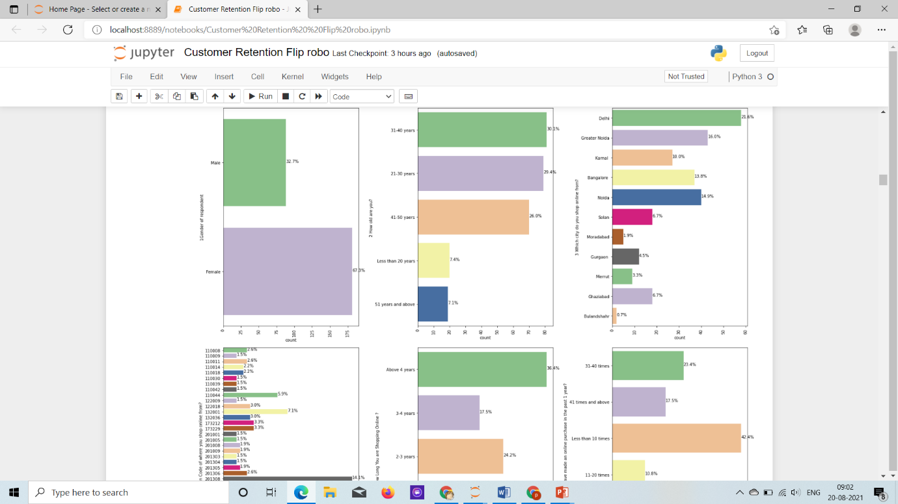

* Larger Proportion of customer are Female around 67% of the customers.
* Between the Age Group of 31-40 has 30%, After from the age of 21-30 people are 29%, Then 41-50 group with 26% of the customers. those who are less 20 and 50 are only 7%.
* Largest proportion of the customers are from pincode code 201308 that 14% of the total customers, Next Highest count of customers are from pincodes 201310, 132001, 110044 with 6.7%, 7.1% and 5.9% respectively, other than than all pincodes have between 1-4% of the count of customers.
* Customers above 4 in q4 how long have you been shopping online. 36% of customers have been shoping onlnie >4 years, 23% of the customers have been shopping onlnie for 2-3 years, 17% of the customers are shopping online for 3-4 years, 16% of the customers have been shopping for Less than 1 year. Least Percent of data with 5% have been shopping onlnie for 1-2%. we can sAY 75% OF the customers have shopping online more than 2 years.
* How many times purchases have been made in last year, 42% of the customers have made purchases < 10 times in last year. 23% of the customers have made 31-40 times purchases made in last year. Least count of customers have made purchases with 21-30 times with 3.7%, 41 and 42 times and above combined have 19% of the customers.
* 21% shop from Delhi, then Greater Noida with 16% and Noida with 14%. Least percetn of customers purchases from Bulandsher 0.7% and muradabad 1.7%.
* 70% of Customers accessing the internet while shopping onlnie with Mobile Internet, 28% of the Customers access internet through Wifi, with 1.5% of customers with dial-up.
* 52% of the customers uses Mobile device to shop, then 32% of the customers use Laptops, 11% of customers use desktops and 4.5% of customers uses Tablets with LEast Count.
* Screen Size of the Customers using mobile device, 36% of the mobile users have 5.5Inch screen size, 49% of the customers are others i.e(laptop/tablet/desktop screen users) , least count of 5 inch mobile screens with 2.6% of the customers.

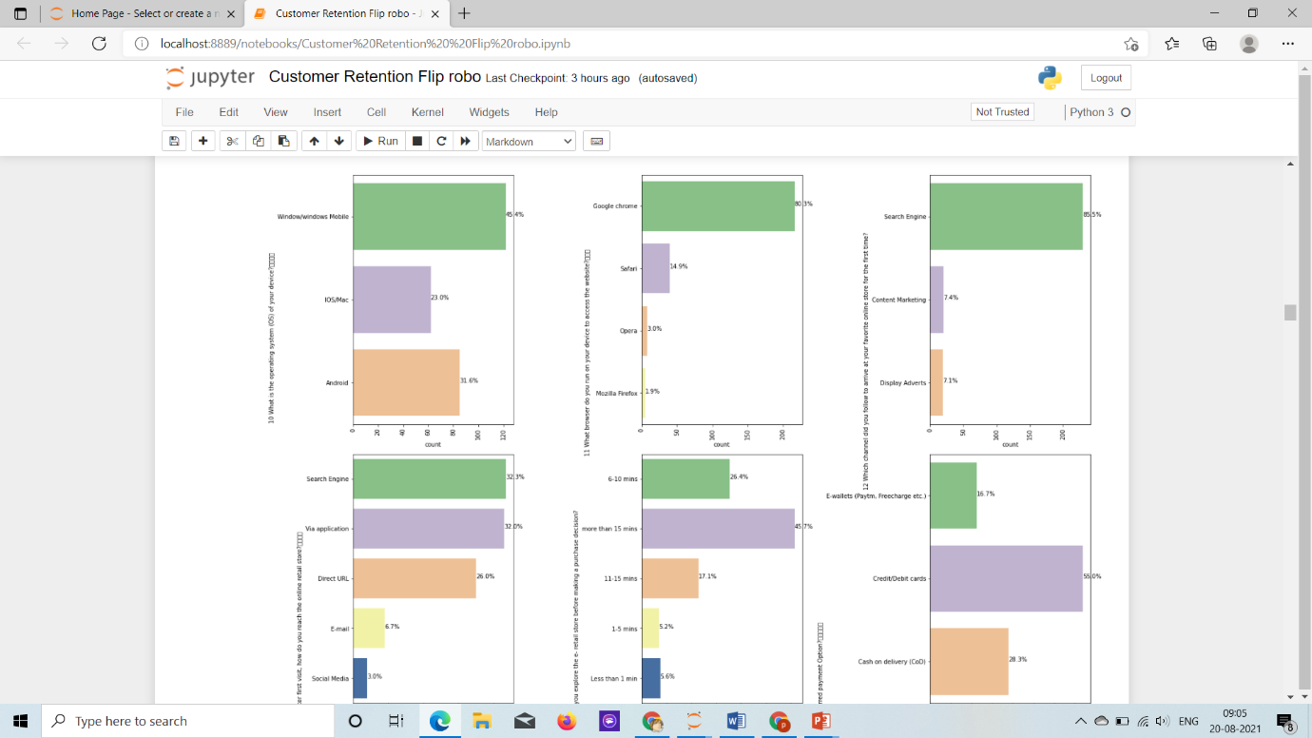

Information on a similar product to the one highlighted is important, 43% of the customer strongly agree and 34% of the customers agree to it, least % of customers i.e 6.7% of them disagree to the question above, 16% of the customers think the question is indifferent.

Complete information on listed seller and product being offered is important for purchase decision, 37% of the customers strongly agree to the question, where as 32% of the customers agree to the question, 19% of the customers feel the question is indifferent, 6.7% of the customers strongly disagree, 4% of the customers disagree to the question.

All relevant information on listed products must be stated clearly, 49% of the customers Agree to the question, where 40% of the customers Strongly agree to the question, 6.6% of the customers strongly disagree to the question, and 4.4% of the customers dis-agree to the question.

Ease of navigation in website, the question is strongly agreed by 52.4% of the customers, 39% of the customers agree to it, 6% of the customers strongly disagree to it and at the least 1.8% of the customers disagree to the question.

Loading and processing speed, 42%, 41% of the customers strongly agree and agree to the fact respectively, and 6.6% of the customers dis-agree to the question, where as 4.4 % of the customers strongly disagree / feel indifferent respectively.

User friendly Interface of the website, 70% of the customers storngly agree to it, 16% of the customers Agree to it, where as 6.6% of the customers strongly disagree and 4.4% of the customers disagree and 1.8% of the customers find the fact indifferent at least.

Convenient Payment methods, 59% of the customers strongly agree, 29.7% of the customers Agree to it and at least 11% of the customers disagree to it.

Trust that the online retail store will fulfill its part of the transaction at the stipulated time, 52% of the customers agree to the fact, 32% of the customers Agree to the Fact, 11% of the customers Disagree to the Fact, 4.4% of the customers find it indifferent.

Empathy (readiness to assist with queries) towards the customers, 72% Of the customers strongly agree, 15.6% of the customers agree to it, 6.6% of the customers strongly disagree to it, 5.5% of the customers find it indifferent fact.

Being able to guarantee the privacy of the customer, 68% of the customers strongly with the question, 21.5% of the customers agree to it, 9.6% of the customers find the question indifferent.

Responsiveness, availability of several communication channels (email, online rep, twitter, phone etc.), 55% of the customers strongly agree to it, 34% of the Customers agree to the question, 5.5 of the customers find it indifferent, 4% of the customers strongly disagree.

Online shopping gives monetary benefit and discounts, 39% of the customers strongly agree ot the fact, 31.5% of the customers Agree to the Fact, 18% of the customers find the fact indifferent, 6.6% of the customers strongly disagree to the fact, 4% of the customers disagree to the fact.

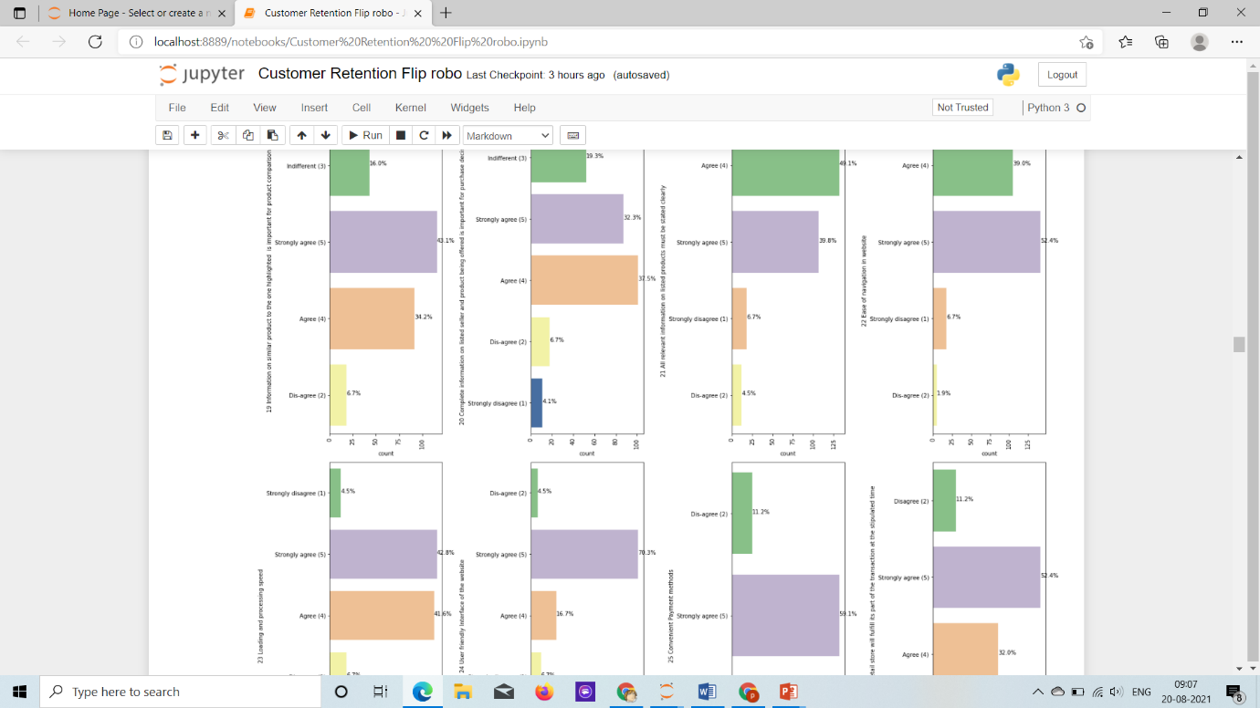

enjoyment is derived from shopping online, all customer have biased opions as 30% of the customers strongly agree, 28% of the customers find the fact indifferent, 21% of the customers agree to the fact and other customers disagree.

Shopping online is convient and flexible, majority of the customers(54%) strongly agree and 29% of the customers Agree to it.

Return and replacement policy of the e-tailer is important for purchase decision, majority of the customers(73%) strongly agree and 18% of the customers Agree to it and other remaining(7.5%) disagree.

Gaining access to loyalty programs is a benefit of shopping online, majority of the customers(42%) strongly agree and 23% of the customers Agree to it, 23% of the customers find the fact indifferent, and other remaining are in disagree and strongly disagree category.

Displaying quality Information on the website improves satisfaction of customers, majority of the customers(50%) stronlyg agree and 29% of the customers Agree to it and other remaining(21%) find it indifferent.

User derive satisfaction while shopping on a good quality website or application, majority of the customers(65%) strongly agree and 31% of the customers Agree to it and other remaining(2%) disagree.

Net Benefit derived from shopping online can lead to users satisfaction, majority of the customers(60%) stronlyg agree and 20% of the customers Agree to it and other remaining(15%) feel the fact is indifferent and other 4% disagree.

User satisfaction cannot exist without trust, majority of the customers(45%) strongly agree and 43% of the customers Agree to it and other remaining(1.8%) feel the fact is indifferent and other 2.6% and 6.7% of the customers disagree and strongly disagree.

39 Offering a wide variety of listed product in several category, majority of the customers(41.2%) strongly agree and 34% of the customers Agree to it and other (21%) feel the fact is indifferent and other 2.6% disagree.

Provision of complete and relevant product information, majority of the customers(50.2%) strongly agree and 36% of the customers Agree to it and other (11%) feel the fact is indifferent and other 1.8% disagree.

Monetary savings, majority of the customers(55%) strongly agree and 27% of the customers Agree to it and other (5.5%) feel the fact is indifferent and other 11% disagree.

The Convenience of patronizing the online retailer, majority of the customers(51.3%) agree and 20% of the customers strongly Agree to it and other remaining(28.6%) feel the fact is indifferent.

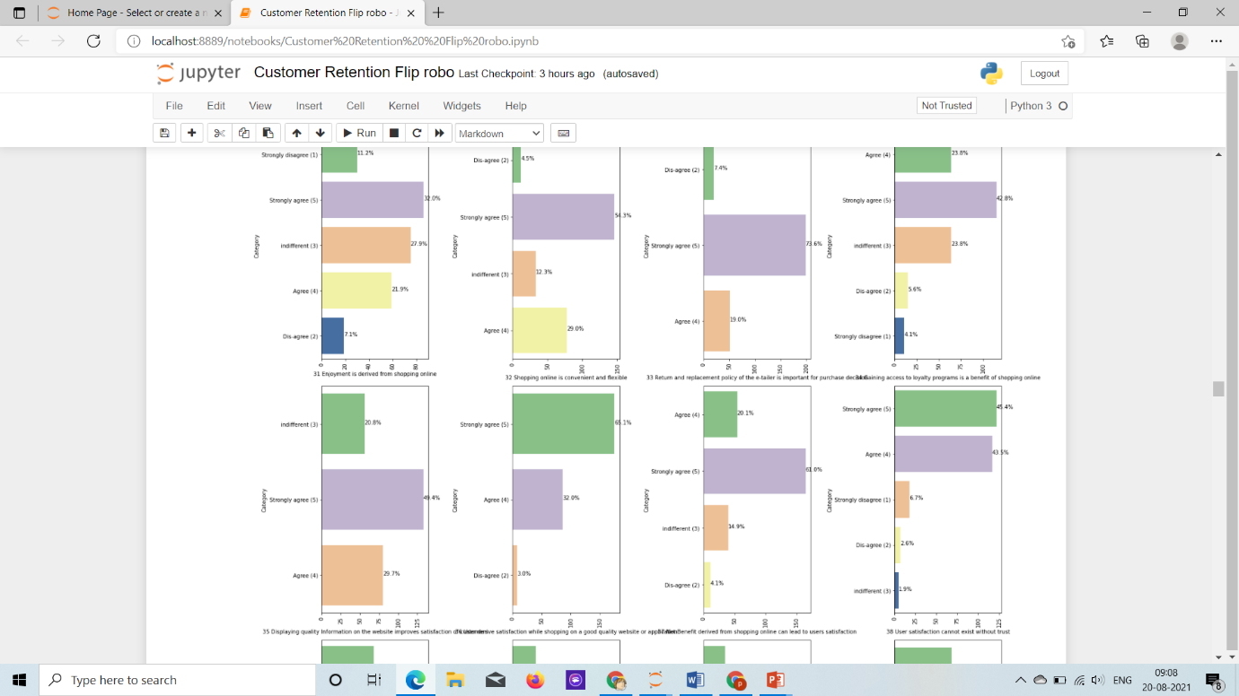

Shopping on the website gives you the sense of adventure, majority of the custormers(38%) agree to it, 20% of customers strongly agree, 22% of the customers find the fact indifferent, 18.5% of the customers disagree, 1.8% of the customers strongly disagree.

Shopping on your preferred e-tailer enhances your social status, majority of the custormers(37%) find it INdifferent, 17.8% of customers strongly agree, 21% of the customers agree to it, 12% of the customers strongly disagree, and remaining 10% of the customers disagree to it.

You feel gratification shopping on your favorite e-tailer, 37% of the customers find it indifferent, 24% of the customers strongly agree to it, 23% of the customers agree to it, and other 8% and 6% of the customers disagree and strongly disagree to it respectively.

Shopping on the website helps you fulfill certain roles, 32% of the customers find the fact indifferent and agree to it Each, 14% of the customers strongly agree to it, 12% of the customers storngly disagree and the remaining 8% of the customers disagree to it.

Getting value for money spent, majority of the customers (55%) Agree to it, other 30% of the customers strongly agree it it and other remaining 14% of the customers find it indifferent.

From the following, tick any (or all) of the online retailers you have shopped from, we observe majority of the customers (30%) of the customers shop from all the online relatilers i.e (Amazon.in, Flipkart.com, Paytm.com, Myntra.com, Snapdeal.com), 16% of the customers shop from all the Website Except paytm , 11% of the customers shop from Amazon and Flipkart, 10% of the customers shop from all the Website Except MYntra, 10% of the customers shop from amazon, Flipkart and Snapdeal, 7.4% of the customers shop from amazon, paytm, myntra, 5% of the cusotmers shop only from Amazon, 4.4% of the customers shop from paytm and amazon, 2.6% of the customers shop from amazon, flipkart and paytm. WE observe all the Customers shop from Amazon, Other than people have differnet preferences.

majority of the customers find all the relatiler online store (Amazon.in, Flipkart.com, Paytm.com, Myntra.com, Snapdeal.com) easy to use.

Majority of the Customers(32%) find Amazon and flipkart layout of website appealing, 16% of the customers find only AMazon website appealing, 14% of the customers find all the websites appealing.

Wide variety of products on offer, majority of the customers 49% find amazon and flipkart website products on offer.

Complete relevant description of the product, 38% of the customers find it in amazon/flipkart. other 16% customers only find relevant product desc in amazon, and for other combination of website all liw in range of 5-10%.

Model Buiding

Validation Score with Accuracy Score: 1.0

Training Score with Cross Validation Score: [1. 1. 1. 0.97297297 1. ]

CLASSIFICATION REPORT precision recall f1-score support

0 1.00 1.00 1.00 64

1 1.00 1.00 1.00 37

2 1.00 1.00 1.00 29

3 1.00 1.00 1.00 13

4 1.00 1.00 1.00 3

micro avg 1.00 1.00 1.00 146

macro avg 1.00 1.00 1.00 146

weighted avg 1.00 1.00 1.00 146

samples avg 1.00 1.00 1.00 146